The Forehand Volley
A Visual Comparison among Skilled Players

Last month, I wrote on the similarities of the backhand volley mechanics among top players including Rafter, Sampras and Hewitt. In discussing these similarities, I presented reasons why these champions use certain methods, but also why all players should explore these methods for themselves. Within all movements in tennis there is a “cause and effect”, or more specifically, an “effect and a consequence.” This dichotomy often helps describe why certain mechanics are desirable while others are counterproductive in terms of developing skilled strokes. The forehand volley is no exception to this theory. Here, I will break down the core elements that most skilled players utilize in their production of successful forehand volleys.
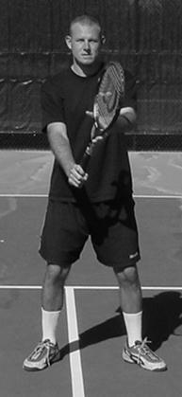

The Forehand Volley: An Overview
Essentially, on a foundation scale, the forehand volley is a “mirrored image” of the backhand volley. While there are a couple key components that differ, the majority of each stroke components mimic each other on many levels.
Certainly, there are many ways to “hit” a forehand volley. An excursion to some of the local public parks will attest to this statement. However, if we are analyzing the ways in which skilled players hit a volley, we narrow down the diversity considerably. It is to this extent that I break down the key points of a progressive forehand volley

Grip
As most books and pros will attest, skilled players use the Continental grip for almost all their volleys. Although, in some cases, skilled players will attack certain volleys with a slight Eastern forehand grip. These usually include higher volleys or swinging topspin volleys. (Since the topspin volleys are hit with the basic swing pattern as a topspin groundstroke, we will only address the more standard blocking-type or short-stroke volley.) However, almost all top players exclusively use a Continental grip for low volleys and especially for angle volleys. One of the most difficult shots for intermediate players who use the Eastern forehand grip for their volley is the angle volley. (I will address this later.)
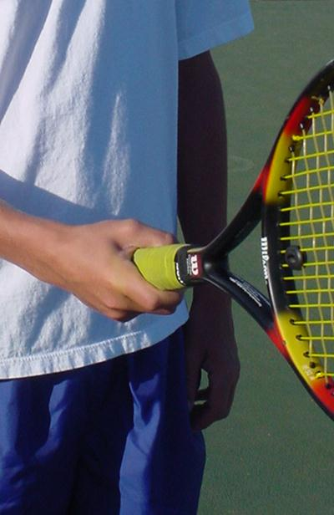
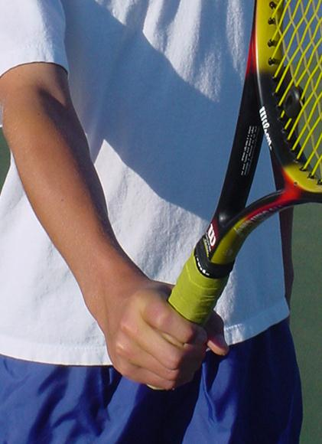
The Eastern forehand grip places more of the hitting hand behind the racket.
Also known as the “hammer” grip, the Continental grip keeps the racket parallel with the forearm.
Since the Eastern forehand grip is so commonly associated with topspin forehand groundstrokes, I always recommend players to first learn to volley with the Continental grip. Players who learn using the Eastern forehand grip for their forehand volley inevitably hit their volleys with topspin. (Especially quick volleys when they don’t have time to think), After all, the Eastern forehand grip is designed for topspin! I have seen hundreds of players who KNOW they should slice the volley, hit with topspin because of this natural swing pattern the Eastern grip produces.
The Continental grip keeps the racket parallel with the forearm while the Eastern Grip creates nearly a 90 degree relationship to the forearm.
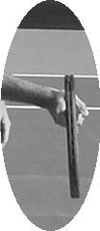
Here, the side view of the Continental grip shows how the racket remains parallel with the forearm.
The Eastern forehand grip tends to make the racket lay back at a 90 degree angle to the forearm.
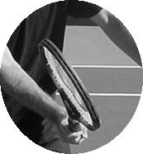

One big issue for many beginners and intermediate players who are trying to learn the Continental grip is comfort. This grip generally feels weak. This is one reason so many books and pros promote the Eastern grip to beginners…it feels better to the player. However, if the Continental grip is desired, it is far better to experience some discomfort now than the incapacitating discomfort of trying to change an established Eastern forehand grip! Here are a couple tools for you to quickly gain comfort and control of the racket while holding the Continental grip.
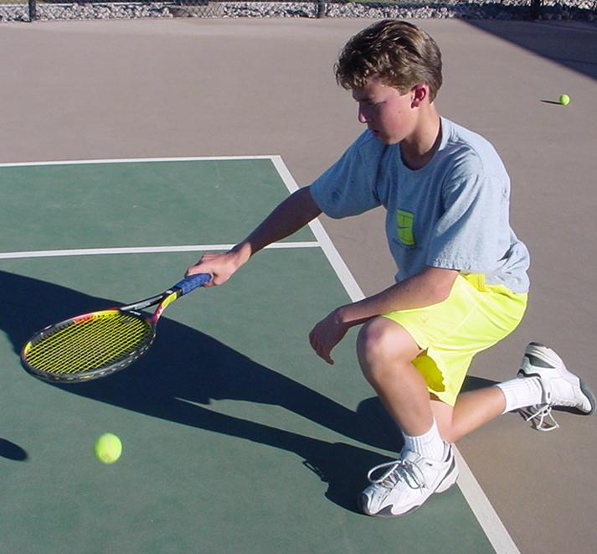

Down Bounces
While holding the Continental grip, kneel down on the right knee (for right handers) and hit about 100 continuous bounces. Hold the grip firm but relax the rest of your body. This is an excellent warm-up drill for your arm. This low impact action helps warm up the small muscles and joints of the hand and arm, helping prevent tennis elbow.
Kneeling down helps keep your arm parallel with the racket. Older people can sit in a chair if kneeling is difficult.

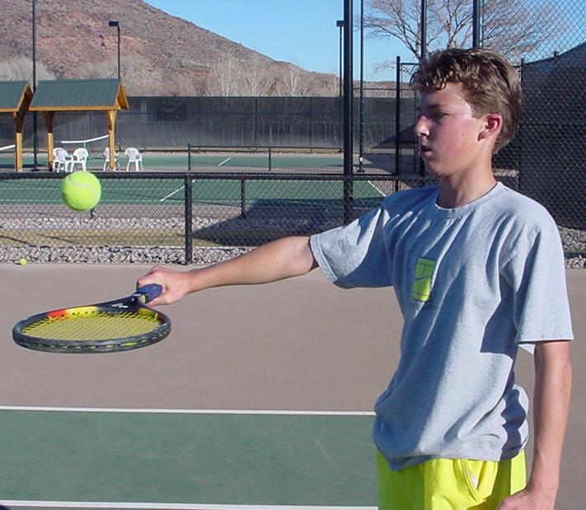

Up Bounces
This action of bouncing balls up from a palm-down position helps the player gain control of the Continental grip. If you keep your elbow straight and the racket parallel and tilted up at a 90 degree angle to your forearm, you are simulating the general backhand volley technique. Keep your arm about chest high. Don’t lift your arm to hit the ball. Let the ball drop to your racket and apply a small firm bump to each bounce. Try to keep the ball between one or 2 feet at the most above the strings on each bounce.

On the issue of strength, if a player feels weak while hitting volleys, it is usually a good sign they are doing something wrong. In seminars and clinics, I demonstrate both the forehand and backhand volley using only my index finger and thumb. A result of seeing crisp, deep volleys using only these two fingers, students begin to recognize that strength is not the issue when hitting volleys. (Certainly for hard hit balls and balls hit out of our reach, there is an element of strength necessary to simply control the racket. However, even in these instances, a good volley rarely needs the kind of strength players think is necessary.)

First Move
As with the backhand, the first move is the shoulder turn. Usually, the forehand volley turn is slightly less than is necessary for the backhand. This is because of the arm and shoulder position on the two shots. On the forehand, the dominant arm and shoulder for a right-handed player is back in comparison to the center point of the body. On the backhand, these two body parts are in front of the player center point. Some pros advise students to take the racket back to the side first. However, this sequence causes many to over swing. The reason is simple: if you take the racket back to the side first, then turn the shoulders, the racket will be pointing towards the back fence!
Using the Continental grip, the turn of the shoulders sets the face of the racket towards the target.
Sampras Volley

Turn still picture
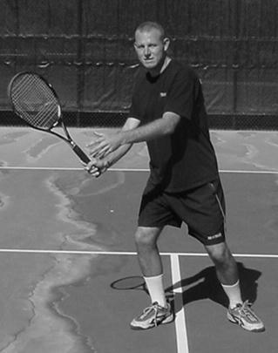
Agassi Forehand volley turn

Still
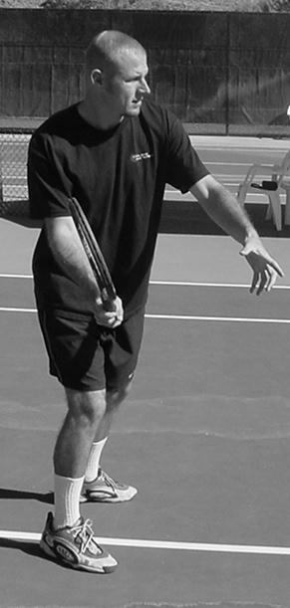

Foundation: Early turn of the shoulders

Key Position Points on the first move: Racket head remains up, the racket remains parallel with the forearm, and the left arm contributes to the shoulder turn.

Step
With volleys where we have time to set up our feet, the left leg will step across the body facilitating the sideways position that is critical to directing the shot without pushing. As with the backhand volley, the ability to stroke the volley towards the target depends on the body’s ability to hit while sideways to the target.
If you watch all skilled players angle the volley crosscourt, they will actually align their body so that they are facing away from the target during contact.
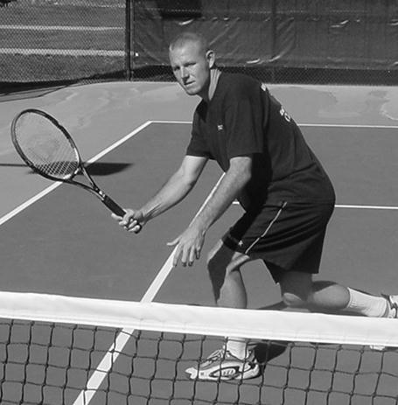
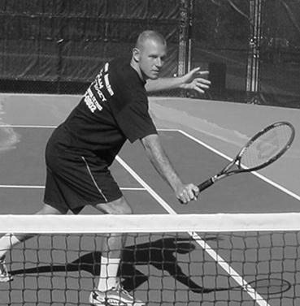
Notice in both the forehand and backhand angle volley, the player turns away from the target.

Contact

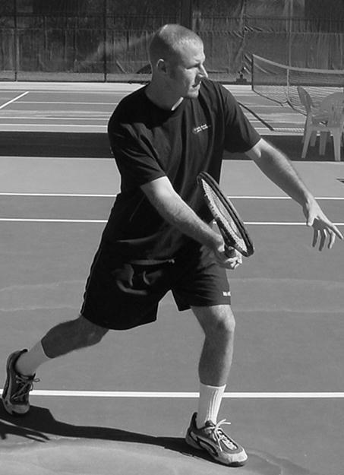
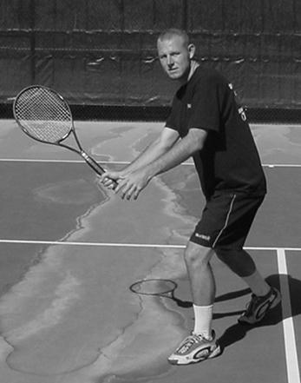
McInroe contact
Hingis Contact

As with the backhand volley, the forehand volley is hit almost parallel with the front knee. This can vary from player to player, however. For example, players who do hit using a slight Eastern forehand grip will tend to push out their hand in front of them in attacking a short floater. It is important that the player learn to move their feet and body to attack balls instead of simply leaning and reaching forward. This is a common problem for many players as it tends to make players hit the ball flat and down into the net.
As with the backhand, most forehand volleys are hit with a slight slicing motion. The amount of slice can vary due to situations and desired effect. Some players will flatten out a volley with just a minimal amount of slice, usually on high volleys. On lower volleys, players will usually add a greater amount of slice to the ball so they can hit it firm without hitting it out. The action of slicing the ball will help maintain the racket face during contact. Without the slicing action, players often hit down too much, volleying a ball that is high above the net down into the net.
Short clip showing contact

Player hitting a low, slicing volley

(Davenport, Forehand volley, front view, low.)

Key Position Points: Unlike the backhand where the player should try to keep the hitting arm straight, the arm on a forehand volley can and should be slightly bent. Player should try to keep the eyes parallel with the ball at contact.
Show sampras here (forehand volley crosscourt front view)

Finish
Pros use a decidedly longer finish than I recommend most beginners to high intermediate players. Traditionally, those players just starting out use a bigger swing than they can control. A longer follow-through usually is preceded by a big backswing. Players learn the volley better when they hold their finish momentarily. This allows them to check their racket’s position in relation to their arm and body, as well as checking the racket’s face after contact. (If they are rolling the racket or hitting topspin, this will be revealed by a closed racket fact after contact.) Watch in this video of Sampras as he too holds his finish for a moment after contact. After the slice, his racket still clearly faces the target.
Note the contact point just off the front knee. Sampras adds slice to this crosscourt for control

Back Leg
A common problem, especially for beginners it the aspect of keeping the back leg back during the forehand volley. Often, players will thrust their hand out to hit the volley, instead of moving their feet to the ball. This forward movement of the hand and arm usually causes the player to be out in front of their center of gravity. Thus, the player has to quickly swing their leg around to help them from falling on their face. This rotation of the hips and back leg causes players to open up too early.
Keep the back leg back at contact.

Conclusion
Successful forehand volleys are those that can be hit with regularity to a variety of targets from a variety of positions. Players who execute volleys using the Continental grip usually progress to higher advanced stages of play due to their ability to hit with greater variety, especially low volleys and angle volleys. Eastern grips are often used, even by the pros. Yet, it is clear that almost all skilled players will hit the majority of their volleys using the Continental grip. More importantly, in players looking to develop a skilled volley, the use of the Eastern grips may delay or even prohibit this acquisition of a quality volley. Even when skilled players used the Eastern forehand grip to volley with, the emphasis of the racket in a slice-like pattern is obvious.
Once the volley grip and short stroke are mastered, players must utilize their feet to maximize the position and body relationship to the ball.
Finally, you will see a variety of forehand volleys among even top players. However, if you look close, you will identify these core elements even within the diversity and idiosyncrasies among the many highly skilled performers.

