Last month, I wrote on the similarities of the backhand volley mechanics among top players including Rafter, Sampras and Hewitt. In discussing these similarities, I presented reasons why these champions use certain methods, but also why all players should explore these methods for themselves.
Still of Pete Sampras
(Use: Forehand - Down the Line - Court Level - Front View, contact point)
Here, I will break down the core elements that most skilled players utilize in the production of successful forehand volleys through the same use of visual comparisons of several top players.

The Forehand Volley
Essentially, on a foundation scale, the forehand volley is a “mirrored image” of the backhand volley. While there are key components that differ, among most top players, the forehand and backhand volleys mimic each other on many levels.

Grip
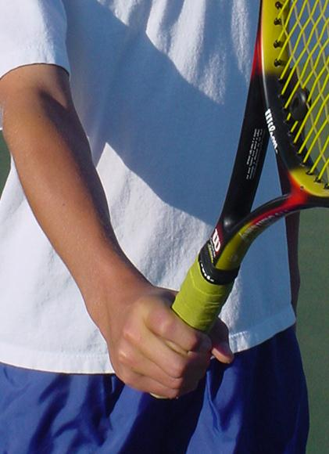
As most books and pros will attest, skilled players use the Continental grip for almost all their volleys. Although, in some cases, skilled players will attack certain volleys with a slight Eastern forehand grip. These usually include higher volleys or swinging topspin volleys. (Since the topspin volleys are hit with the basic swing pattern as a topspin groundstroke, we will only address the more standard blocking-type or short-stroke volley.) However, almost all top players exclusively use a Continental grip for low volleys and especially for angle volleys.
Players who learn to volley using the Eastern grip for their forehand volley inevitably hit their volleys with topspin. This is even more evident on quick volleys when reaction time is limited. After all, the Eastern forehand grip is designed for topspin! I have seen hundreds of players who know they should slice the volley, hit with topspin because of this natural swing pattern the Eastern grip produces.
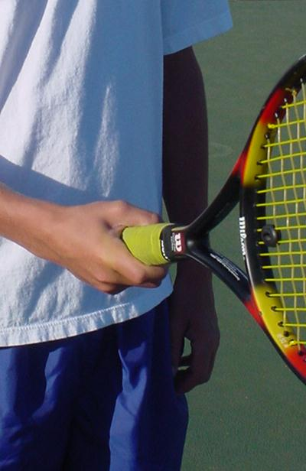
The Continental grip keeps the racket parallel with the forearm while the Eastern Grip creates nearly a 90 degree relationship to the forearm.
One big issue for many beginners and intermediate players who are trying to learn the Continental grip is comfort. The Continental generally feels weak - a major reason so many books and pros promote the Eastern grip to beginners…it feels better to the player. However, it is far better to experience some discomfort now than the incapacitating discomfort of trying to change an established Eastern forehand grip! Here are a couple tools for you to quickly gain comfort and control of the racket while holding the Continental grip.
Two important drills I use to help students gain comfort and control using the continental grip is the use of ball bounces. However, many instructors recommend standing up while doing these. Standing almost forces players to use an Eastern grip! When bouncing the ball down, kneel down so the racket and the arm can remain parallel. On up bounces, stand and keep the racket and arm parallel as well, and keep the racket elbow straight. This drill helps develop a proper backhand volley.
On the issue of strength, if a player feels weak while hitting volleys, it is usually a good sign they are doing something wrong. In seminars and clinics, I demonstrate both the forehand and backhand volley using only my index finger and thumb. As a result of seeing crisp, deep volleys using only these two fingers, students begin to recognize that strength is not the issue when hitting volleys. (Certainly for hard hit balls and balls hit out of our reach, there is an element of strength necessary to simply control the racket. However, even in these instances, a good volley rarely needs the kind of strength players think necessary.)
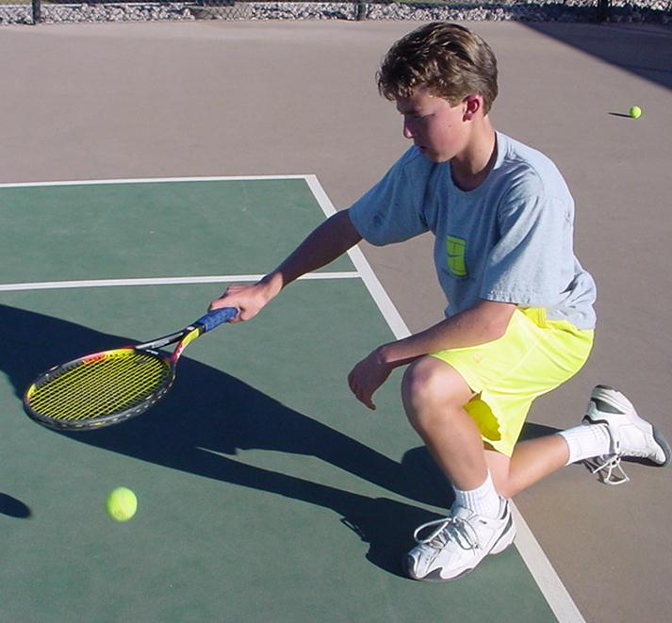
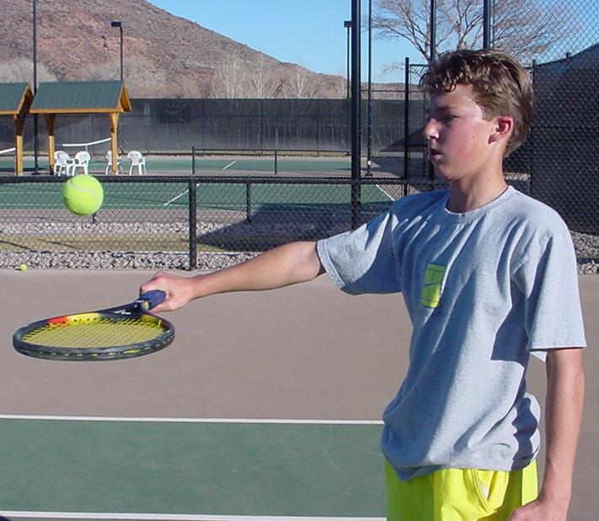
Bounces: Learn to bounce kneeling down to simulate the forehand volley.
Up bounces: Keep the racket parallel with the arm and at a right-angle to the forearm.

First Move
As with the backhand, the first move is the shoulder turn. Usually, the forehand volley turn is slightly less than necessary for the backhand. This is because of the arm and shoulder position on the two strokes. On the forehand, the dominant arm and shoulder for a right-handed player is back in comparison to the center point of the body. On the backhand, these two body parts are in front of the player's center point. Some pros advise students to take the racket back to the side first prior to the shoulder turn. However, this sequence causes many to over swing. The reason is simple: if you take the racket back to the side first, then turn the shoulders, the racket will be pointing towards the back fence!
Pete at split step
(Use: Forehand - Low - Front View)
Pete at initial turn showing shoulders turned, racket to the side.

(Use: Forehand - Low - Front View)
Pete at contact

(Use: Forehand - Low - Front View)

Using the Continental grip, the turn of the shoulders sets the face of the racket towards the target.
Key Position Points on the first move: Racket head remains up, the racket remains parallel with the forearm, and the left arm contributes to the shoulder turn.
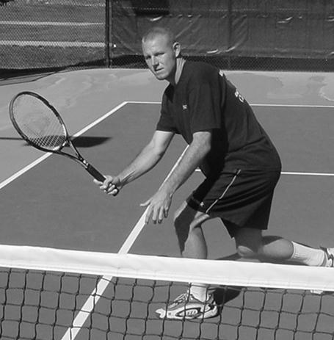

Step
With volleys, when there is time to set up the feet, the left leg will step across the body facilitating the sideways position. (For right-handed players.) This is a critical factor in directing the shot without pushing. As with the backhand volley, the ability to stroke the volley towards the target depends on the body’s ability to hit while sideways to the target. If you watch skilled players angle the volley crosscourt, they will actually align their body so that they are facing away from the target during contact.
Forehand volleys include the crossover step demonstrated here. Note the sideways body position in hitting a crosscourt angle volley.
Skilled players can often be seen actually stepping out with what I call the “wrong foot”. (Right foot for right-handed players.) The issue is that skilled players have developed the proper shoulder position regardless of which foot they step with. Beginners to intermediate players often step out with this wrong foot without executing the shoulder turn. This results in the player pushing the volley away from the body instead of the arm moving across the body.
Contact of Patrick Rafter
(Use side view 3)

Catch the actual contact point if possible.

Contact
As with the backhand volley, the forehand volley is hit almost parallel with the front knee. This can vary slightly from player to player, however. For example, players who do hit using a slight Eastern forehand grip will tend to push out their hand in front of them when attacking a short floater. It is important that players learn to move their feet and body to attack balls instead of simply leaning and reaching forward. This is a common problem for many and it tends to make players hit the ball flat and usually down into the net.
Patrick Rafter hits mid to high forehand volleys with a slight Eastern forehand grip. However, notice the contact point just off his front leg.
As with the backhand, most forehand volleys are hit with a slight slicing motion. The amount of slice can vary due to situations and desired effect. Some players will flatten out a volley with just a minimal amount of slice (usually on high volleys). On lower volleys, players will usually add a greater amount of slice to the ball so they can hit it firmly and still keep it on the court. The action of slicing the ball will help maintain the racket face during contact. Without the slicing action, players often hit down too much, volleying a ball that is high above the net into the net.
Video Clip:
Lindsay Davenport
Use: Forehand Volley—front view. (first one on her prostrokes list, both shots)
For most volleys, skilled players apply a slight cut or slice at contact.
Skilled players who have excellent rackethead control can oftentimes be seen hitting a forehand volley relatively flat. As long as the player maintains the proper racket face angle during a flat volley, this can be accomplished with success. However, from my experience, recreational to intermediate competitive players often misjudge this necessary angle or, they turn the racket face down slightly at contact, a common problem for many players.
Key Position Points: Unlike the backhand where the player should try to keep the hitting arm straight, the arm on a forehand volley should be slightly bent. The eyes should try to remain parallel to the ball height at contact.
McEnroe Video Clip
(Use “side view” on the forehand volley)
Occasionally, on situational volleys, a player will hit a flat volley. Notice how McEnroe keeps the racket firm and square with a decidedly short backswing

Finish
Pros use a decidedly longer finish than I recommend for most beginners or high intermediate players. Traditionally, club players starting out use a bigger swing than they can control. A longer follow-through usually is preceded by a bigger backswing. I recommend holding the finish momentarily. This allows a player to check the racket’s position in relation to the arm and body, as well as the racket’s face after contact. (If they are rolling the racket or hitting topspin, this will be revealed by a closed racket fact after contact.) Watch in this video of Sampras as he too holds his finish for a moment after contact. After the slice, his racket still clearly faces the target.
Video of Pete
(use forehand crosscourt front view)
Notice how Pete holds his follow-through for a brief moment. Beginners to top players can benefit from this.

Back Leg
Video of Davenport
(Use forehand volley front view both hits)
A common problem, especially for beginners is the aspect of keeping the back leg back during the forehand volley. Often, players will thrust their hand out to hit the volley, instead of moving their feet to the ball. This forward movement of the hand and arm usually causes the player to be out in front of their center of gravity. Thus, the player has to quickly swing their leg around to help them from falling on their face. This rotation of the hips and back leg causes players to open up too early.
Notice how Lindsay Davenport keeps her hips sideways and the back leg back long after contact has been made.

Conclusion
Successful forehand volleys are those that can be hit with regularity to a variety of targets from a variety of positions. Players who execute volleys using the Continental grip usually progress to higher advanced stages of play due to their ability to hit with greater variety, especially low volleys and angle volleys. Eastern grips are often used, even by the pros. Yet, it is clear that almost all skilled players will hit the majority of their volleys using the Continental grip. More importantly, in players looking to develop a skilled volley, the use of the Eastern grips may delay or even prohibit this acquisition of a quality volley. Even when skilled players use the Eastern forehand grip to volley with, the emphasis of the racket in a slice-like pattern is obvious.
Along with mastering the grip and short swing pattern, players must utilize their feet to maximize the position and body relationship to the ball.
Finally, you will see a variety of forehand volleys among even top players. However, if you look close, you will identify these core elements even within the diversity and idiosyncrasies among the many highly skilled performers.

